**DURING THIS WINTER BREAK WE STRONGLY ENCOURAGE OUR STUDENTS TO WORK ON**

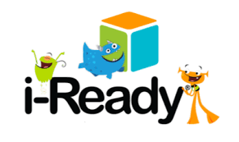

**MATH AND ENGLISH LANGUAGE ARTS (ELA). STUDENTS CAN ACCESS THEIR i-Ready PLATFORM VIA LAUNCH PAD.**

**PARENTS, PLEASE HAVE YOUR YOUNG SCHOLAR WORK ON EACH SUBJECT AREA FOR A MINIMUM OF 30 MINUTES PER SUBJECT AREA EACH DAY THAT THEY ARE HOME. AS STUDENTS WILL BE TAKING THEIR SECOND i-Ready MATH AND ELA DIAGNOSTIC SOON AFTER THEY RETURN FROM THEIR WINTER BREAK.**



**LET’S TAKE A LITTLE TIME NOW SO THAT OUR YOUNG SCHOLARS CAN SHOW A LOT OF GROWTH.**